**WEBSITE ICOMCOS**

**Konten Menu**

- Home : introduction, objective, and theme about the Conference and Workshop generally

- Call For Paper : interest subject , template (abstract and full paper in word and LaTeX), instructions & guidelines for authors, publication opportunity

- Important Date and Schedule

|  |  |
| --- | --- |
| ***1 May 2020*** | ***Abstract sumission deadline for early bird (batch 1)*** |
| ***15 May 2020*** | ***Acceptance Notification for early bird*** |
| ***22 May 2020*** | ***Payments due for early bird*** |
| ***5 July 2020*** | ***Abstract sumission deadline for batch 2*** |
| ***14 July 2020*** | ***Acceptance Notification for batch 2*** |
| ***20 July 2020*** | ***Payments due for batch 2*** |
| ***3 August 2020*** | ***Abstract sumission deadline for batch 3*** |
| ***17 August 2020*** | ***Acceptance Notification for batch 3*** |
| ***24 August 2020*** | ***Payments due for batch 3*** |
| ***28 September 2020*** | ***Workshop*** |
| ***29 September 2020*** | ***Conference*** |
| ***17 October 2020*** | ***Full Paper Submission Deadline*** |
| ***9 November 2020*** | ***Acceptance Notification*** |
| ***30 November 2020*** | ***Camera Ready Papers Due*** |

- Submission and Registration , for join Conference and Workshop

- Fee and Payment , berisi list biaya dan cara pembayaran

|  |  |  |  |
| --- | --- | --- | --- |
| Conference Fees | | | |
| **Participants** | **Batch 1** | **Batch 2** | **Batch 3** |
| Undergraduate Student | IDR 1.300.000 | IDR 1.600.000 | IDR 1.900.000 |
| National | IDR 1.700.000 | IDR 2.000.000 | IDR 2.300.000 |
| International | $ 150 | $ 180 | $ 200 |

- Keynote Speaker, berisi profil keynote speaker / invited speaker

- Committee and Contact Person, berisi daftar panitia SC (biasanya ada yang dari luar) dan OC beserta email resmi dan nomor cp yang bisa dihubungi

**ORGANIZING COMMITTEE**

General Chair : Professor Win Darmanto, PhD

Executive Chair : Chairman of Mathematics Department

Program Committee Chair : CicikAlfiniyah, PhD

Program Committee Co-Chair : M. FarizFadillahMardianto, M.Si.

Workshop Chair : Dr. Eridani

Publication Chair : DrWindarto

Conference Programme : Dr. LiliekSusilowati (Coordinator)

NenikEstuningsih, M.Si

EndahPurwanti, MT

Marisa Rifada, M.Si

Secretariat : Abdullah Jaelani, M.Si (Coordinator)

SitiMaghfirotulUlyah, MSc

Purbandini, MT

NaniaNuzulia, MT

AsriBektiPratiwi, M.Si

Bustomi, M.Si

Yayak, S.Si

Armi J., M.Si

QuintanSuri, S.Si

Finance : SitiZahidah, M.Si (Coordinator)

Indah W., S.Si

Facilities and Decoration : EtoWurianto, M.Sc (Coordinator)

M. Yusuf Saifuddin, M.Si

Suliyanto, M.Si

Taufik, MT

Transportation : FaridEffendy, MT (Coordinator)

Muhammadun, M.Si

Sponsorship : KartonoFaqih, M.Sc (Coordinator)

Sediono, M.Si

Logistics : Elly Ana, M.Si (Coordinator)

Inna Kuswandari, M.Si

Conference Website : Edi Winako, M. Cs (Coordinator)

BadrusZaman, M.Kom

Publicity and Documentation : HerrySuprajitno, Ph.D (Coordinator)

Aziz, ST

Yayak, S. Si

Khoni I., ST

Reza, ST

**SCIENTIFIC COMMITTEE**

Dr. Fatmawati (Mathematics, UniversitasAirlangga, Indonesia)

Dr. EbenzerBonyah (Applied Mathematics, Ghana)

Prof DediRosadi (Statistics, UGM, Indonesia)

Prof I NyomanBudiantara (Statistics, ITS, Indonesia)

Prof. Dr. HadiSusanto (Applied Mathematics, Khalifah University, Abu Dhabi)

Dr. NurChamidah (Statistics, UniversitasAirlangga, Indonesia)

Ira Puspitsari, Ph. D (Computational Science, UniversitasAirlangga, Indonesia)

Dr. Windarto (Mathematics, UniversitasAirlangga, Indonesia)

Dr. RimulyonoHendradi (Computational Science, UniversitasAirlangga, Indonesia)

Dr. TohaSaifuddin (Statistics, UniversitasAirlangga, Indonesia)

Dr. LilikSusilowati (Mathematics, UniversitasAirlangga, Indonesia)

Dr. Eridani (Mathematics, UniversitasAirlangga, Indonesia)

Dr. Moh. Imam Utoyo (Mathematics, UniversitasAirlangga, Indonesia)

Dr. Miswanto (Mathematics, UniversitasAirlangga, Indonesia)

DrArdiKurniawan (Statistics, UniversitasAirlangga, Indonesia)

HerrySuprajitono, Ph. D (Mathematics, UniversitasAirlangga, Indonesia)

Eva Haryati, M.Si (Computational Science, UniversitasAirlangga, Indonesia)

- Venue and Accommodation , berisi lokasi konferensi dan workshop (google map) , bagaimana cara menuju konferensi , dan tempat rekomendasi di Surabaya (tempat wisata, souvernir, dan kuliner)

**ABOUT SURABAYA AND EAST JAVA**

Surabaya is the capital of [East Java](https://en.wikipedia.org/wiki/East_Java" \o "East Java) Province, which is the [second-largest city](https://en.wikipedia.org/wiki/List_of_largest_cities_and_second_largest_cities_by_country" \o "List of largest cities and second largest cities by country) in Indonesia, after [Jakarta](https://en.wikipedia.org/wiki/Jakarta" \o "Jakarta). The city has a lot of interesting sights. The following are among the important Land Marks:

* Mount Bromo (*Gunung Bromo*) is an active [volcano](https://en.wikipedia.org/wiki/Volcano) andone of the most visited tourist attractions in [East Java](https://en.wikipedia.org/wiki/East_Java), [Indonesia](https://en.wikipedia.org/wiki/Indonesia). The volcano belongs to the [BromoTenggerSemeru National Park](https://en.wikipedia.org/wiki/Bromo_Tengger_Semeru_National_Park" \o "Bromo Tengger Semeru National Park). The name of *Bromo* derived from [Javanese](https://en.wikipedia.org/wiki/Javanese_language) pronunciation of [Brahma](https://en.wikipedia.org/wiki/Brahma), the [Hindu](https://en.wikipedia.org/wiki/Hindu) creator god.

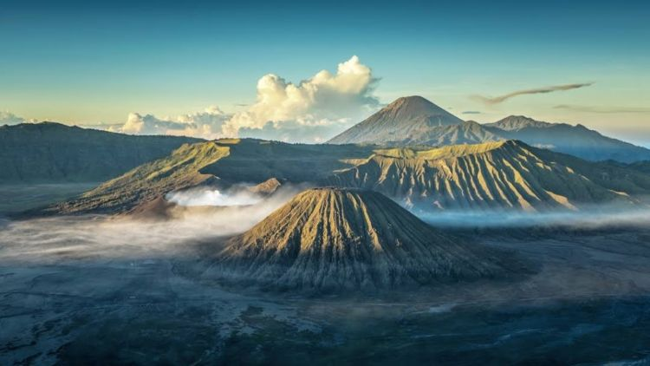

**Gunung Bromo**

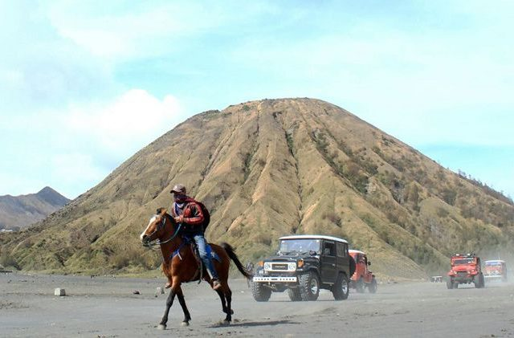

**GumukPasirBromo**

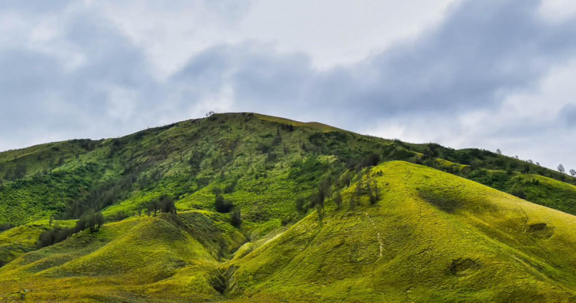

**Bukit Teletubbies**

* *KebunBinatang Surabaya* ([Surabaya Zoo](https://en.wikipedia.org/wiki/Surabaya_Zoo)) opened in 1916. It was the first in the world to have successfully bred [orangutans](https://en.wikipedia.org/wiki/Orangutan) in captivity.

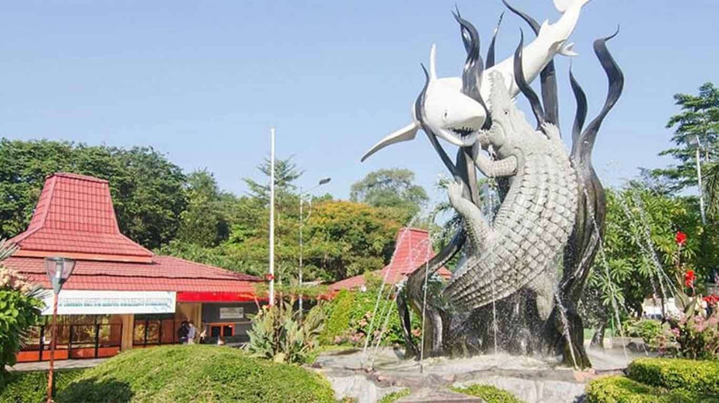

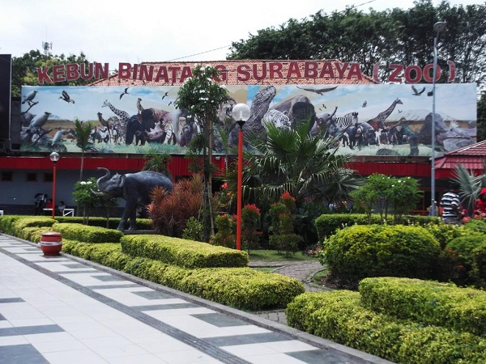

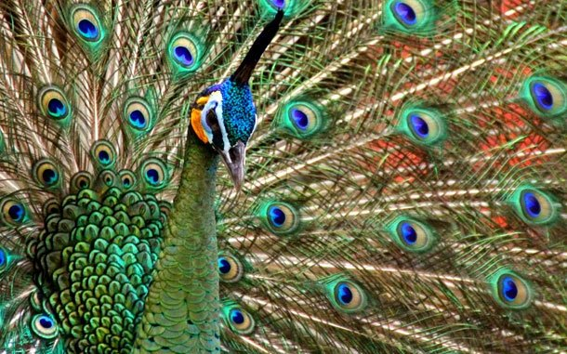

* The Suramadu Bridge (Indonesian: JembatanSuramadu) opened in June 2009 is a cable-stayed bridge between Surabaya on the island of Java and the town of Bangkalan on the island of Madura in Indonesia. This 5.4-km bridge is the longest in Indonesia. Beside, Jaddih Hill is one of an interesting destination in Madura Island. It is a place of traditional white brick mining, which is a perfect place for photography objects.

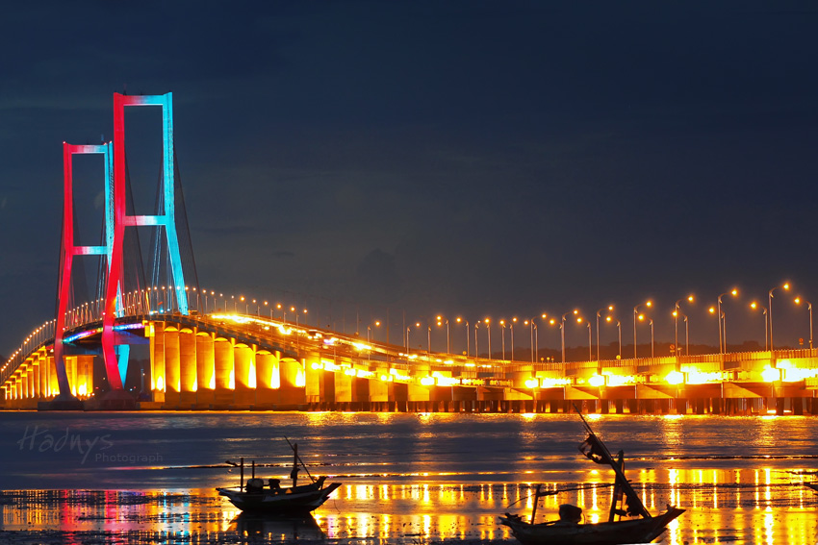

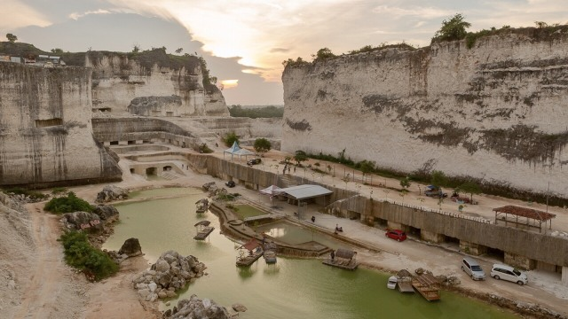

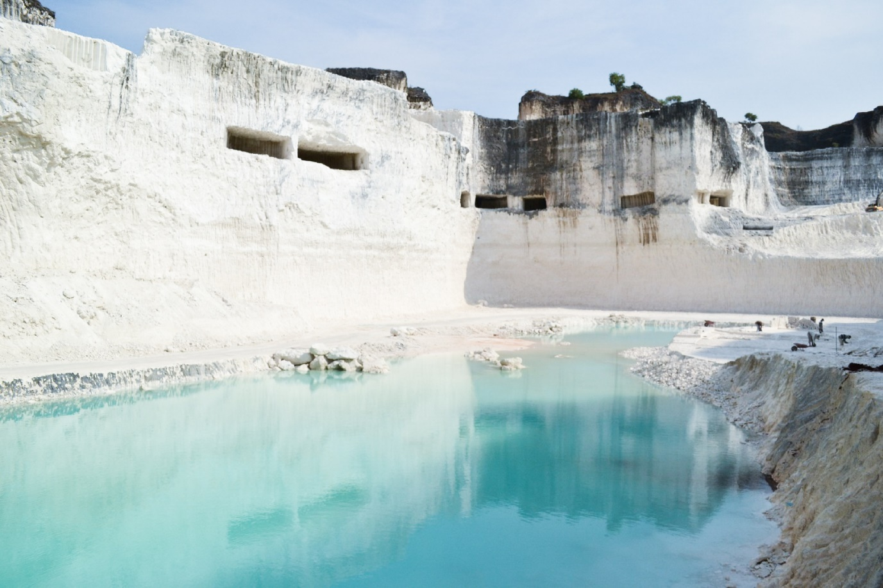

* Relics of history in the classical era such asTrowulan sites in Mojokerto, once the center of the Majapahit Kingdom and dozens of temples.

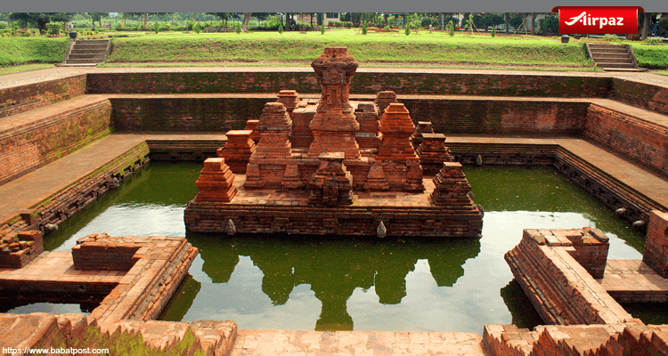

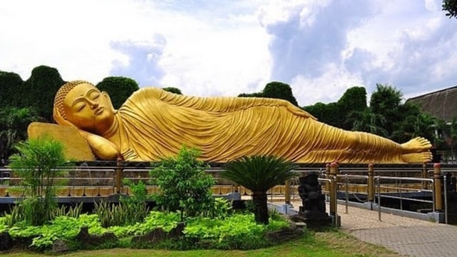

* East Java is known for its coastal scenery. Among others include Kenjeran Beach, located in the eastern of Surabaya, which also housed [SanggarAgung](https://en.wikipedia.org/wiki/Sanggar_Agung), a Chinese temple build over the sea, Prigi Beach, Pelang Beach and PasirPutih Beach in Trenggalek, and Popoh Beach in Tulungagung.

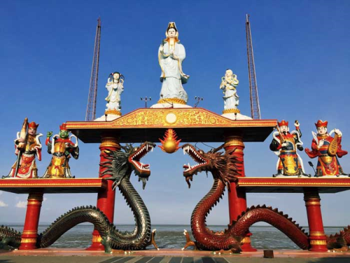

SanggarAgungKenjeran

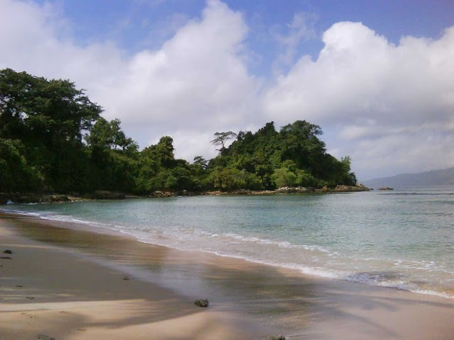

PantaiPrigi, Trenggalek

* Cultural attractions, arts, cuisine, and national parks.